**Congressional Review (CR)**

In accordance with DoDI 5400.04, OSR conducts an accurate and timely security and policy review process to ensure that DoD information is available to Congress to help them understand Defense policy, national security issues and activities. The information to Congress is in the form of witness statements, Advance Policy Questions, Questions for the Record, Inserts for the Record, Hearing Transcripts, Reports to Congress, Budget Reprogramming Actions, Selected Acquisition Reports, and the DoD portion of the annual President’s Budget.

**Congressional Budget**

Several challenging “seasons” occur for the Office of Security Review. One of them is the rush to get the DoD portion of the President’s Budget reviewed by OSR so it can receive final coordination and approval by OMB and be sent to Congress IAW rules by early February (usually February 5th) each year. Of course, other security review requests do not taper off during this period as demonstrated in the graph shown below but continue to grow linearly. This seasonal phenomenon can best be understood by examining the Congressional Budget Act of 1974 in further detail.

The Congressional Budget Act (CBA) of 1974 (Titles I-IX of P.L. 93-344, 88 Stat. 297-332) established the congressional budget process, which coordinates the legislative activities on the budget resolution, appropriations bills, reconciliation legislation, revenue measures, and other budgetary legislation. Section 300 of this act provides a timetable (see milestones below) so that Congress may complete its work on the budget by the start of the fiscal year on October 1.

**Actual Page Count Graph**

**for 2012 DoD Budget Cycle Caseload**

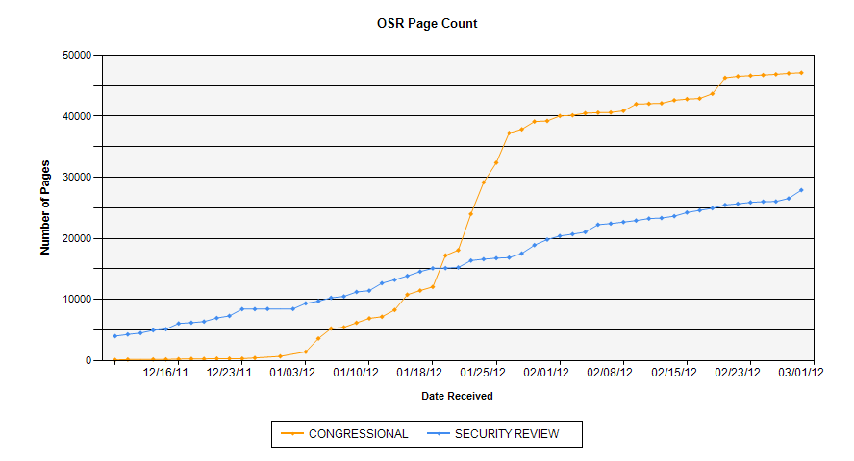

**Congressional Budget Process Timetable**

**Date Action to be completed:**

***First Monday in February*** President submits budget to Congress

***February 15*** Congressional Budget Office submits economic and budget outlook report to Budget Committees.

Six weeks after President submits budget - Committees submit views and estimates to Budget Committees.

***April 1*** Senate Budget Committee reports budget resolution.

***April 15*** Congress completes action on budget resolution.

***July 15*** President submits mid-session review of his budget to Congress.

***October 1*** Fiscal year begins.